Exercise 2

SE 3800 001

Gorecki, Nicholas

Completed: 10/3/2018 23:00

Clone Command: git clone git@gitlab.com:msoe.edu/se/3800/goreckinj/ex2-goreckinj.git

Configuring my account with an SSH key:

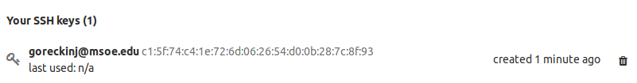

I can push without having to enter my password:

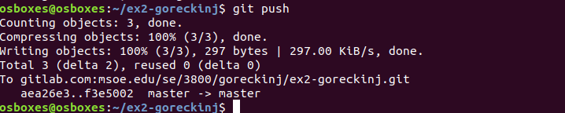

PIPELINE:

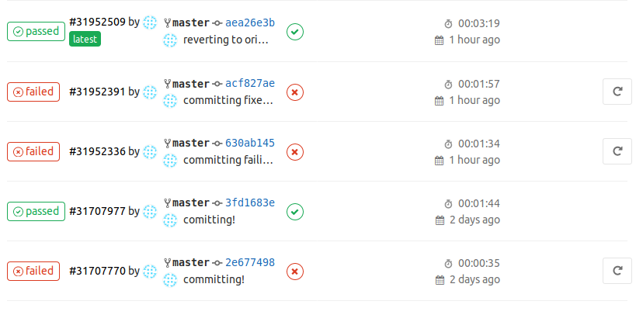

Running Pipeline with all tests passing:

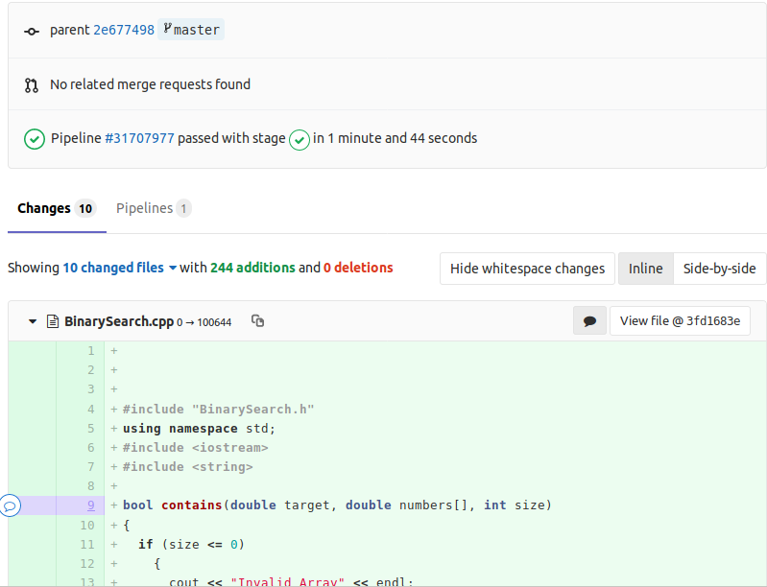

Running Pipeline with tests failing:

The following code boxed in yellow was changed from a 1 to a -1. This makes it so that if the number being searched for is greater than the currently compared number, it will shift left rather than right in the array:

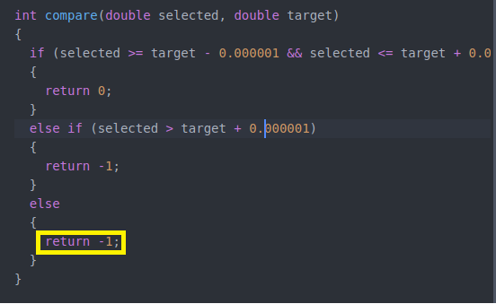

Here’s what happens when the new change is then committed:

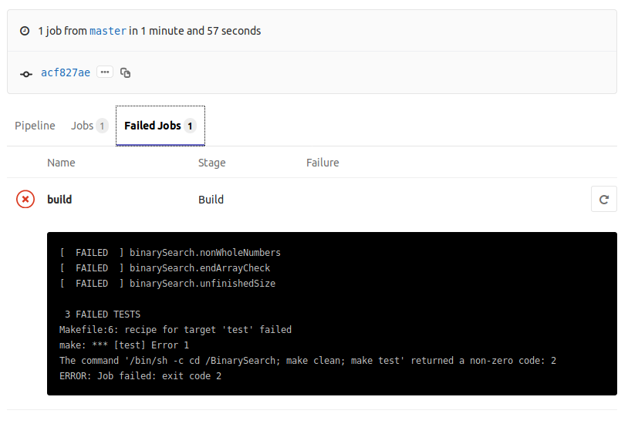

CPPCHECK:

Checks Passing:

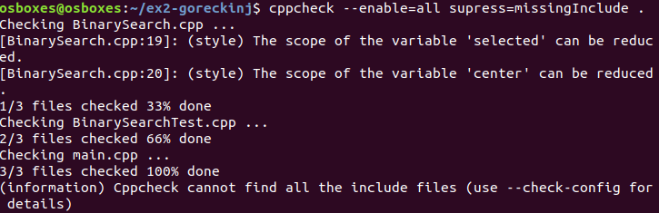

Check Failing:

I commented out where the variable that is the center of the selected array portion is stored. This means that the center variable will never have an assigned value. This should throw an error, since it is used later on in the code.

The result:

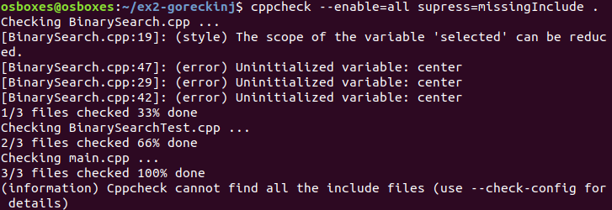And it does. We have three errors in regard to the center variable and the center variable is used three more times in that method:





